MVI56-PDPMV1 to S7-315-2DP

The following document is designed to assist a user in configuring a ProFibus DP V1 master (PDPMV1) ProSoft module to a Siemens S7-315-2DP processor.

The first step in this configuration is the setup of the Siemens processor through Step 7.

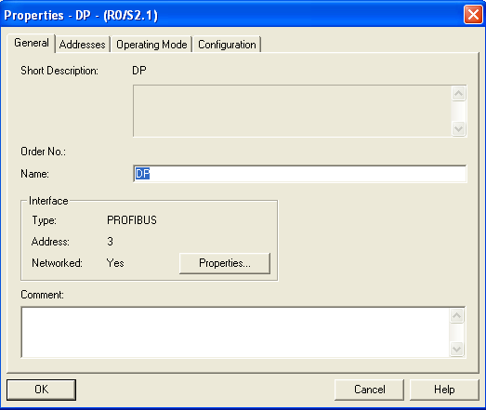

Click on the tab to pull up the following menu:
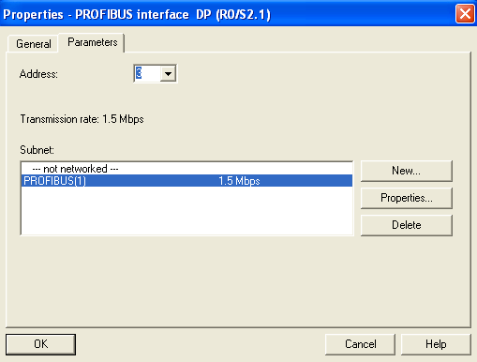

Within this menu, we set the Profibus network baud rate and the node address for the ProFibus DP port. When this is configured, click on

This will take you back to the Previous menu…
From here select the Operating mode, as a DP Slave.
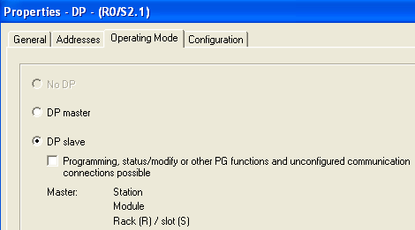

Then go to the configuration menu:
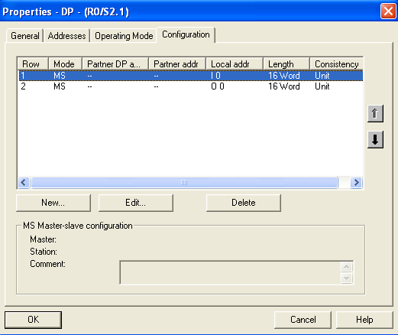

This will setup the addressing within the Siemens processor, and the consistency and the length of the data.
Row 1 takes 16 Words from the ProFibus DP master, and places that information beginning with address I:0 of the S7-315 processor.
Row 2 takes 16 Words from the S7-315 processor, starting with O:0 and places this information out on the ProFibus DP network as Input data.

The following is the configuration used with the PDPMV1 master module, and the setup of the I/O configuration as is done in ProSoft Configuration Builder:

Within PCB, select the Icon, this will bring up the following menu:
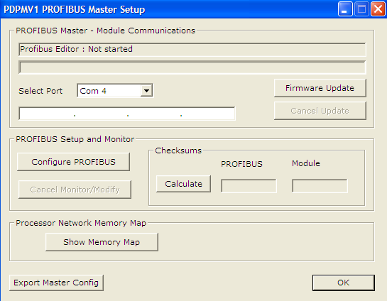

Select the option, you will then get the following menu:
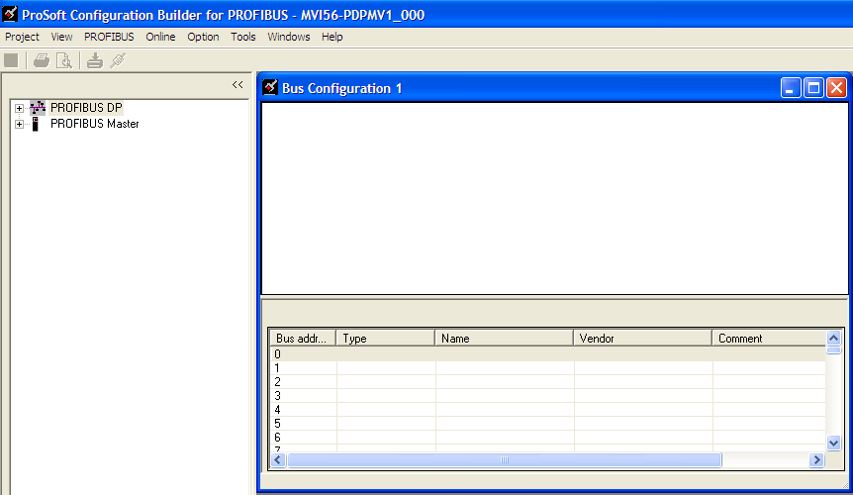

Under the Tools option, we will need to install the GS* file for the slave device, as shown:
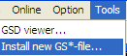

For this example we are using an S7-315-2DP processor as a slave.

After successfully installing the selected GS* file, you will now see the device in your pull down menu:
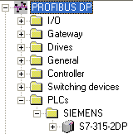

From this project tree, select a master

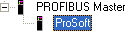

Then pull it onto the Bus Configuration window:
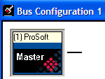

Next, go back to you project tree, and select you slave device:
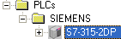

Drag this onto the Bus Configuration window:
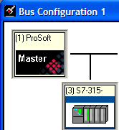

Next, fill the appropriate I/O setup for the module to match the configuration done in Step 7 for the processor. Below is the configuration used based on those settings defined in Step 7:
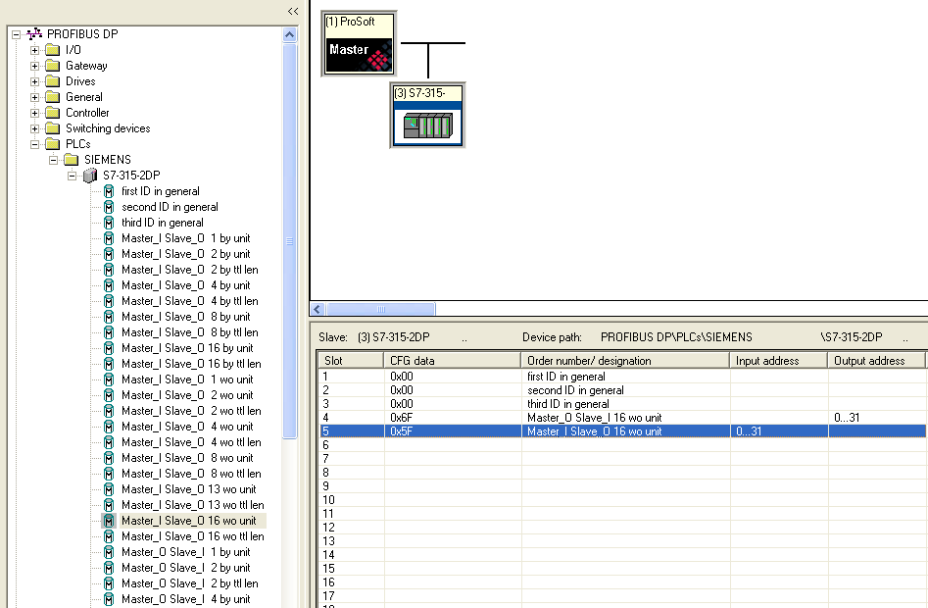

Module’s 1, 2, and 3, are all filled with the First, Second, and Third ID in general tab.
Module 4 is setup as Master_O Slave_I 16 wo unit, to match the configuration outlined for the S7 processor within Step 7.
Module 5 is setup as Master_I Slave_O 16 wo unit, to also match the configuration for the S7-315-2DP processor outlined in Step 7.

In the Bus Configuration window, double click on the slave, this will bring up the Slave properties menu, shown below:
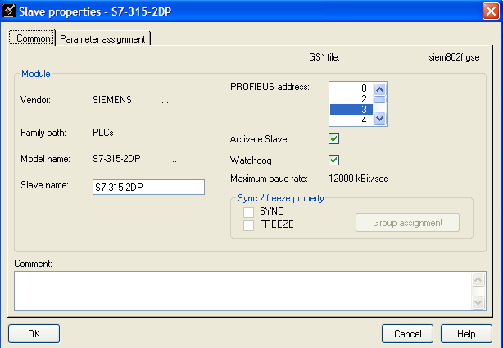

Make sure that the PROFIBUS address, matches the address that was configured for the S7-315-2DP processor within the Step 7 configuration.

Now that all of the configuration for the slave has been defined, do a Project -> Save within the configuration window:

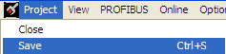

Next close the ProFibus configuration window:

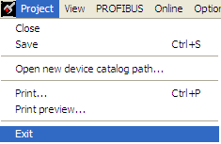
This will bring you back to the following menu:
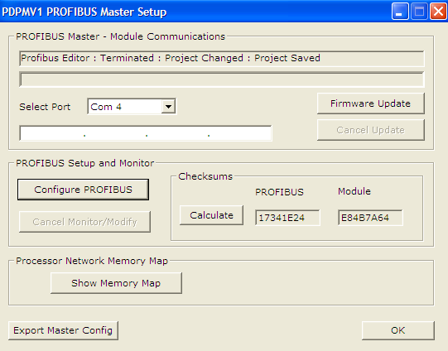

Notice, under the Profibus Editor, you will now see the following:

Click on the tab.

Highlight on the module in the Project Tree, as shown here:
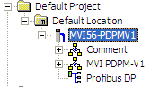

Then do a right mouse click and select the Download option:
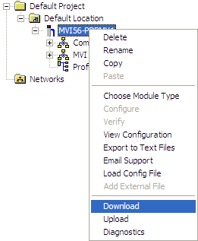

After the utility is done checking for installed serial ports, you will get the following menu:

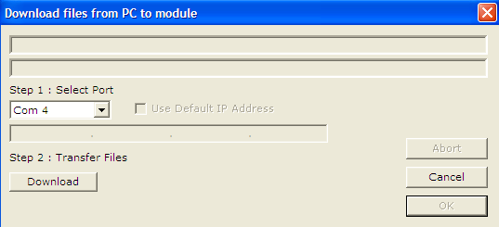

After connecting the cable from you PC’s serial port, to the serial port of the PDPMV1 module, select the option from this window.

When the following window is displayed, place the processor in run mode (if it’s not already in run mode), and press OK.
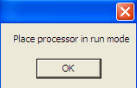
You should now see the from within the Download files menu. Press OK, and you should be up and running.

