**Linking Up Industrial Hotspot Radios**

**Make sure you check the physical layer first:**

Antennas are pointing to each other with correct polarization and have a clear view of each other (Line of Sight)

Ideally, No obstructions in the way (Trees, Buildings, Walls, Metal Objects, etc.)

If they are on a test bench, you could use antennas that come with the module and make sure that the radios are at least 10 feet away from each.

**Make sure all the radios you are trying to link up too have the same:**

Network SSID, Security Mode, Encryption, WPA Phrase

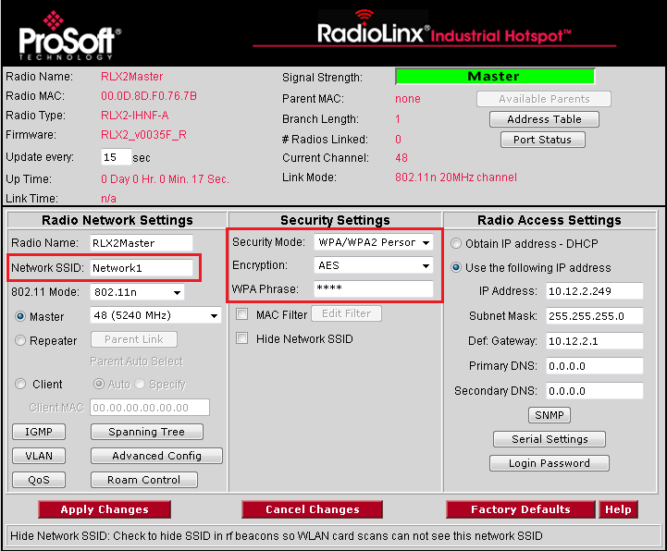

If all those settings are matching you and still get occasional dropouts go into your Spanning Tree Settings.

Make sure all of your radios either have the Spanning Tree all enabled or all disabled.

